**PRAKTIKUM 4**

Nama : Ananta Satya Dhamma

NIM : 18090003

Kelas : 5C

1. Source Code

Web.php => controller

v_index.php => view

v_header.php => view

v_footer.php => view

v_about.php => view

stylebuku.css => css

1. Url

<http://localhost/Pustaka_booking_anan/Web>

<http://localhost/Pustaka_booking_anan/web/about>

1. Capture Output Program

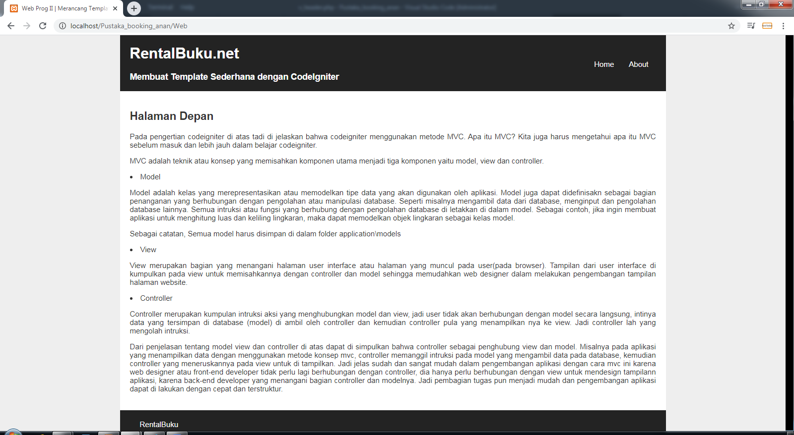**Home**

**About**

